Questions for Authors when Preparing for an anthology book.
Please spend the time to answer the questions below as it will allow us to create a marketing page to help you sell contributors to your anthology. In addition to marketing, it will help our team to ensure that the contributions address the key elements you want to convey.

Once you fill out the document, please send it to submission@thinkaha.com

If you have any questions, please send us an e-mail or give us a call at 408-257-3000.

NOTE: We will be using this site https://www.ahathat.com/CountMeIn which will produce an entry like the following to encourage contributors to join your book

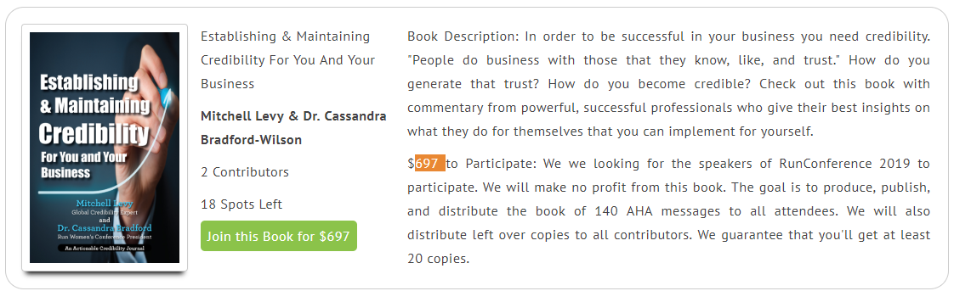

- Who is the reader and what do you want the reader to take away from the book? If the goal of your book is to generate speaking or consulting engagements, or to encourage the sale of a product, why should the reader care about what you're talking about? What is the CPoP (Customer Point of Pain) that you address. Please address these points below:

Who is the Intended Audience? (Please list the types of people you would like to read this book.)

What will the reader take away from this book? (4-5 bullet points describing what the reader will take away after reading this book.)

- What is the suggested title, subtitle, and summary of the book? Also, what questions would you like contributors to answer?
.
Title: (insert title here: the title should address the key pain point you want the book to address)

Subtitle: (insert subtitle here: the subtitle should be longer, but chock full of keywords, and focused on grabbing the attention of your secondary audience

AHAbook Summary:
(insert 1-2 paragraph summary here: The book summary should be salesy (written in 3rd person) and encourage the prospective contributor to participate in the book as well as the prospective reader to want to read and share the book.

Anthology Questions: There are two ways to collect content for an anthology book. After the contributor pays, they can be directed to either 1) a calendar tool to book time so you can interview them or 2) a googleform where we ask a set of questions we want answered. If you want to interview people, please send us the calendar link to use. If you want to have a google form, we'll create it for you, please provide the questions to ask.

- Question 1:

- Question 2:

- Question 3:

- Question 4:

- Question 5:

Keywords (8-15 key phrases): The keywords are used for search-engine optimization so please don't hold back on sharing the appropriate keywords with us.

3) Question about contributors:
- How many contributors would you like:
- We encourage you to create a video where you talk to potential contributors on why they should participate in this book. Please share a YouTube link if you're doing that:
- What price would you like to charge per contributor (Please note that you can have 2 price points if you want to offer a special price and service)?
- For that price, what is the contributor getting. Create a paragraph to be used for marketing. In addition to the number of books, you can include access to you, access to an online training program, a mastermind, or some other service you offer.

4) How do you plan on marketing the book?

List your top 5-10 clients and who might be interested in buying/distributing your book in bulk.

What companies, organizations, associations might be interested in marketing or potential buying your book in bulk.

How many times per year do you speak publicly and what's the typical audience size?

5) What is your name? Please share two types of bios (in 3rd person).

Name:

1-2 Sentence Bio: (For the back of your book)

1-2 Paragraph Bio: (For websites and inside of your book)

Please share a hi-res image of yourself.

